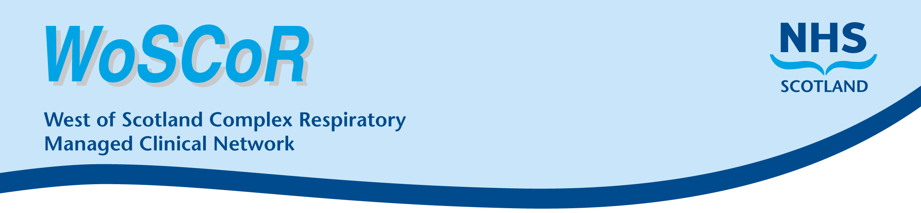

Health board:

Useful Contact Numbers
Service | Name | Telephone No. | When Available
Community Health Team
Paediatric Respiratory Nurse Specialist
GP

Public Health Nurse

Local Hospital |  |  | 24 hours a day  7 days a week
Oxygen delivery, equipment or supplies (tubing, masks etc.) | Dolby (supply) | 0800 833 531

